Project 2

Yahtzee
Version 2

Course
CIS-17A

Section
48969

Due Date
December 11th, 2017

Programmer
Andrew Pena

Introduction:
The Game I decided to program was Yahtzee. It is a fun game I like to play by myself or with friends and family. The game was designed for only for on though. You can play with multiple people but you must first roll dice in game to see who goes first. The Game is also designed to have multiple ways to play. The user can just use the first section in the menu to just roll dice. The third Section could also just be played once to see what one the user can get from one game to practice.

Game Rules:
The Game is to Try to get over 300 points to Win.
Player will roll 5 dice.
After the Roll the player will get to choice which dice He/She wants to keep.
Then after the player choices the dice He/She will roll again.
The Process will repeat until the third roll.
Then the Scores are added and user choices which of the score He/She wishes to keep.
The game continues this process until the scorecard is full.
If the player has 0 for all options then user must choose one regardless and fill it with zero.
Once a user inputs a score in a certain slot the user can no longer use that section again.

Dice Options Information
-------------------------------------------------------------
Player //One Person Plays at a Time
-------------------------------------------------------------
Ones //Total of all Ones
Two //Total of all Twos
Threes //Total of all Threes
Fours //Total of all Fours
Fives //Total of all Fives
Sixes //Total of all Sixes
-------------------------------------------------------------
Sum //Total of all #'s Above
Bonus //Any Bonuses Rewarded
-------------------------------------------------------------
Three of a Kind //Three of Same Dice
Four of a Kind //Four of Same
Full House //One Pair and Three of Same Dice
Small Straight //Four Dice in Sequence
Large Straight //Five Dice in Sequence
Chance //Any Combo with the Sum of all Dice
Yahtzee //All Five Dice the Same
-------------------------------------------------------------
Total //Total Amount of All Scores
-------------------------------------------------------------
When a Yahtzee is rolled an additional 5 points will be rewarded.
If Yahtzee is rolled more than once, Every Yahtzee rolled after the first gets a bonus 50.
If the player gets 63 in the section above sum an additional 35 points will be rewarded.

Development of Summary:
Version 1:
Version one of the gaame was just to make it operational and working. I wanted to see how the game should be broken up into and how the flow of the game might work.

Version 2:
Version 2 of the game is when I started to incorporate the main concepts wanted from the new chapters.
It was more complex while some parts I still couldn't add until next version of the game.

Version 3:
Version 3 I used some concepts but not all to shorten or lengthen the code. I mostly just switch arrays with vectors and made an overloaded operator that didn't need to be there.

Trouble shooting
I had some difficulty with char array for the name for the scoreboard and to return it from a binary file.
I also threw in a little error in the scoreboard if more than one yahtzee was rolled.

Concepts Used:
Chapter 9 Pointers
Chapter 10 String Class
Chapter 11 Structures
Chapter 12 File Operations (binary, reading from certain area,input & output)/ Error File Openings
Chapter 13 Class (constructors/Object-Oriented)
Chapter 14 Static Members/Friends/Aggregation
Chapter 15 Inheritance/Polymorphism/Virtual Function/Abstract Classes
Chapter 16 Exceptions/Class Templates/STL

Diagrams:
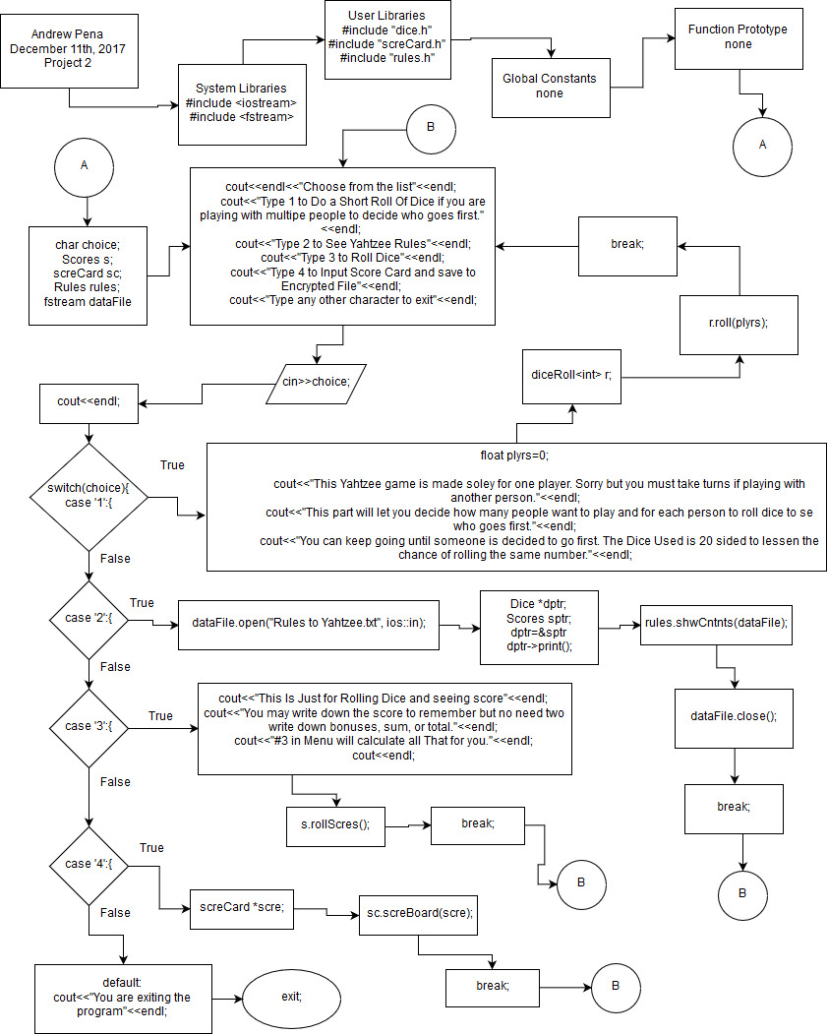

Pseudo code in main (Version 2):
//System Libraries
//Input - Output Library
//File Library
//Name-space under which system libraries exist

//User Libraries
//Dice Header File
//Score Card Header File
//Dice Header File

//Global Constants

//Function Prototype

// Execution begins here!

//Declare Variables
//Choice for Menu Input
//Scores Class Object
//Score
//Rules From File with Operator Overload
//Input File from outside Folder

//Loop on the menu

//Input values for Menu

//User Choice

//Switch to determine the Problem
//case 1
//Declare Variables
//Input for amount of players

//Roll dice Function from class and templates

//Exit stage right!
//break

//case 2
//Open File

//Dice pointer
//Scores Pointer
//Dice pointer to Scores Reference
//Dice pointer to print function from Scores

//Show Contents of Rules from file

//Close File

//Exit stage right!
//break

//case 3
//Info On How to how to keep score

//Uses Variables from Dice Class (Inheritance)

//break

//case 4
//Scorecard Object from Class
//Displays Scoreboard and gets User Input

//break

//default:
//exit program

//Choice loop for While 1-4

//Exit stage right!

